**1372. Longest ZigZag Path in a Binary Tree**

Medium

584 12 Add to List Share

You are given the root of a binary tree.

A ZigZag path for a binary tree is defined as follow:

* Choose **any**node in the binary tree and a direction (right or left).
* If the current direction is right, move to the right child of the current node; otherwise, move to the left child.
* Change the direction from right to left or from left to right.
* Repeat the second and third steps until you can't move in the tree.

Zigzag length is defined as the number of nodes visited - 1. (A single node has a length of 0).

Return *the longest****ZigZag****path contained in that tree*.

**Example 1:**

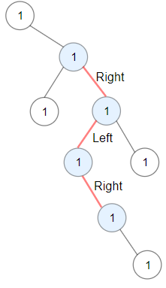

**Input:** root = [1,null,1,1,1,null,null,1,1,null,1,null,null,null,1,null,1]

**Output:** 3

**Explanation:** Longest ZigZag path in blue nodes (right -> left -> right).

**Example 2:**

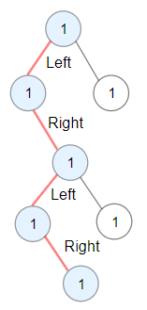

**Input:** root = [1,1,1,null,1,null,null,1,1,null,1]

**Output:** 4

**Explanation:** Longest ZigZag path in blue nodes (left -> right -> left -> right).

**Example 3:**

**Input:** root = [1]

**Output:** 0

**Constraints:**

* The number of nodes in the tree is in the range [1, 5 * 104].
* 1 <= Node.val <= 100

Accepted

19,790

Submissions

35,933